**Practical 03**

**Boot Sequence**

***Access the BIOS Setting***

1. Navigate to settings. You can get there by clicking the gear icon on the Start menu.

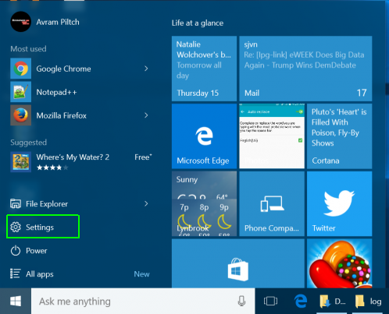

1. click on “Update & Security” at the bottom of the window.

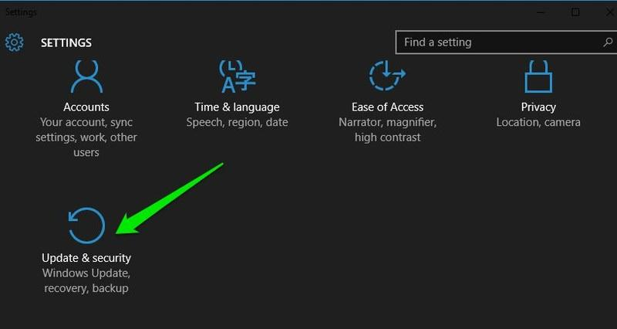

1. Here move to the**“Recovery”** option and click on **“Restart now”** under**“Advanced startup”** option. Your PC will now restart into advanced boot options.

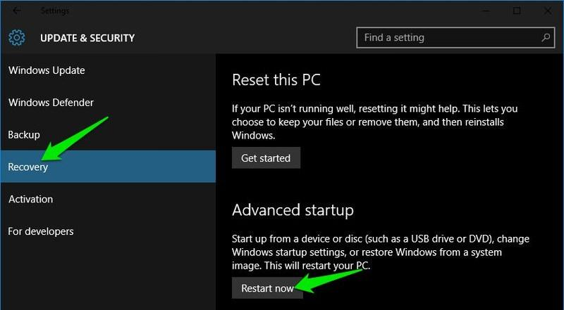

1. **Click Advanced options.**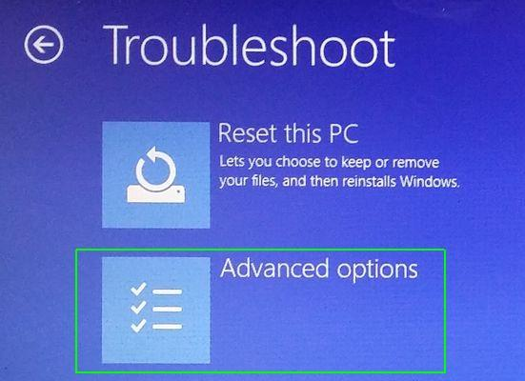
2. **Select UEFI Firmware Settings.**If you don't see this icon, then press Startup Settings, instead. When your PC is restarting, tap F1 (or F2) to access the BIOS.  
   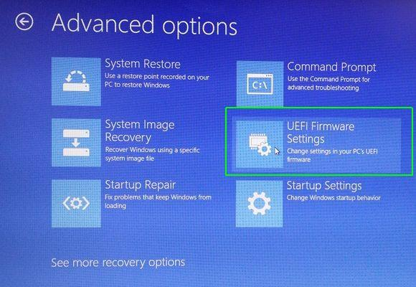

8. **Click Restart.**

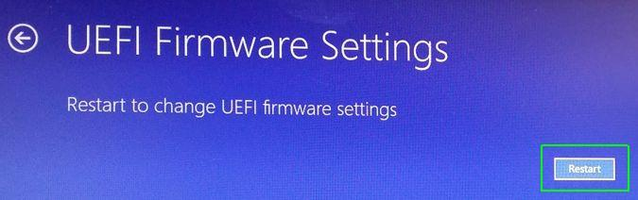

Your system will restart and take you to the BIOS.  
  
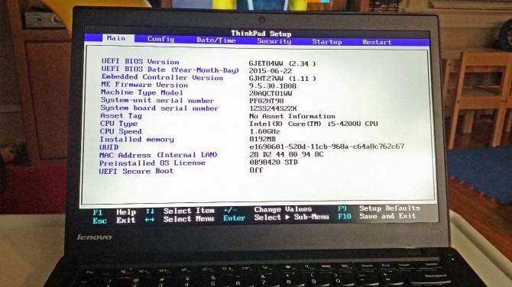

|  |
| --- |
| Windows 10 gives you a lot of options you can configure directly within the operating system, but on every computer, there are some settings you can only change in the BIOS (basic input / output system). The BIOS is the software that is built into your computer's motherboard and controls everything from the boot order of your drives to preboot security options to whether the Fn key on your keyboard activates a function key or a media control.  Unfortunately, because the BIOS is a pre-boot environment, you can't access it directly from within Windows.  Reference: <https://www.laptopmag.com/articles/access-bios-windows-10> |

What are different boot options for your PC? what is BIOS?

|  |
| --- |
|  |

*End of Practical*